Set up these two circuits and complete the statement.

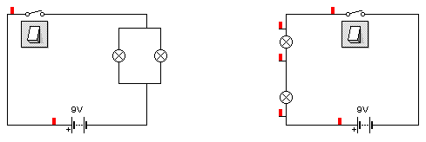Two identical lamps will glow brighter in a _________________ circuit than in a ___________________ circuit.

Set up these two circuits and complete the statement.

Two identical lamps will glow brighter in a _________________ circuit than in a ___________________ circuit.

Set up these two circuits and complete the statement.

Two identical lamps will glow brighter in a _________________ circuit than in a ___________________ circuit.

Set up these two circuits and complete the statement.

Two identical lamps will glow brighter in a _________________ circuit than in a ___________________ circuit.

CHALLENGE

Set up a circuit which allows two switches at either end of a hallway to turn the same light on and off.

